- Install Jenkins and run Jenkins on port number 8081.
Step 1: Launch an instance and connect to it.
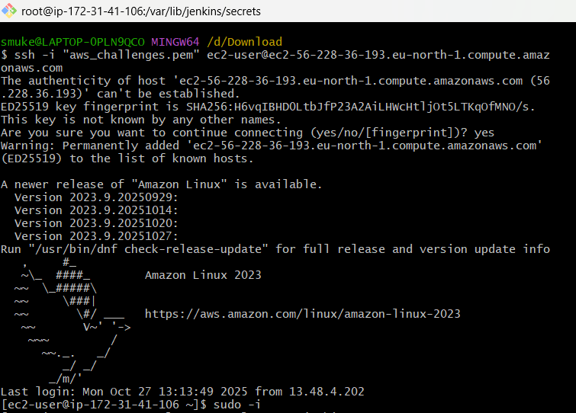
Step 2: Goto official Jenkins website and select Red Hat and run the commands in EC2 instance
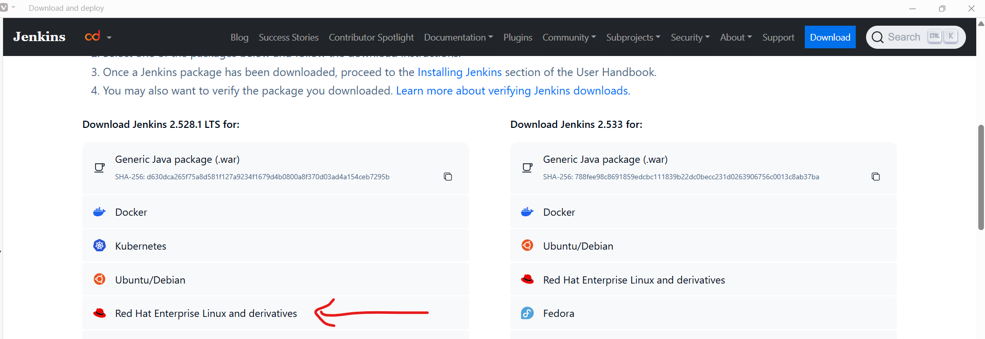
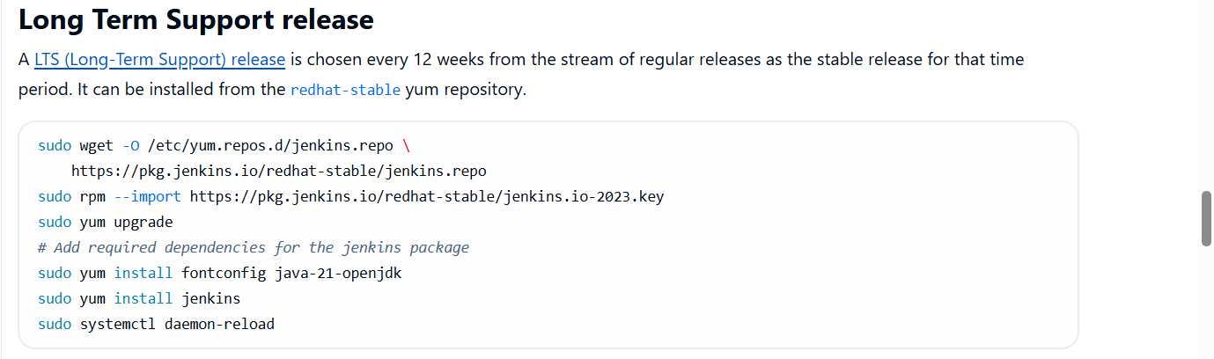
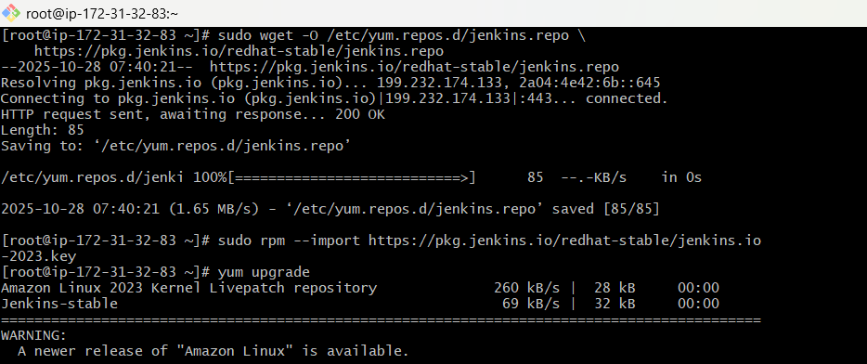
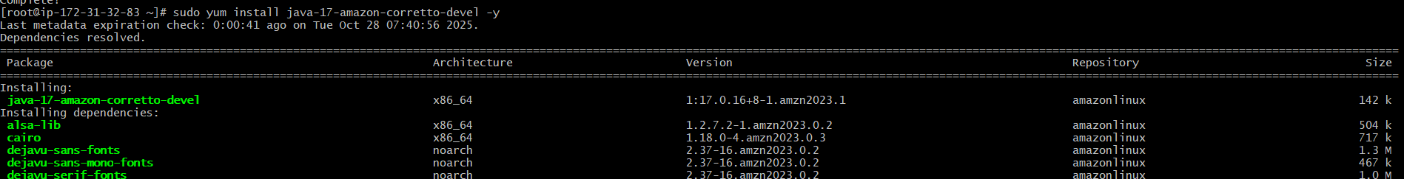
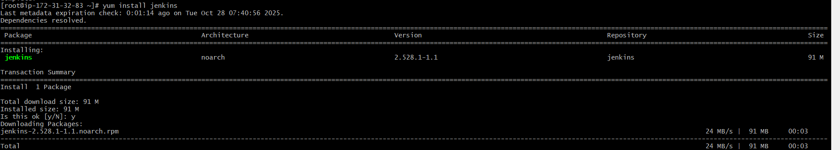
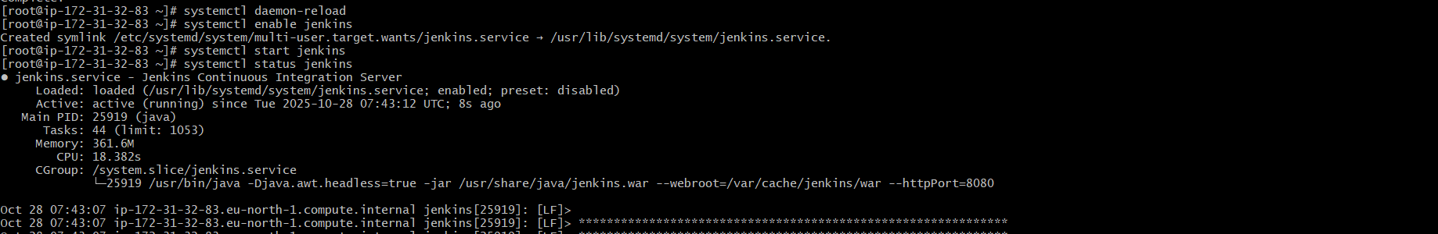
Step 3: Now open Jenkins.service file and change the port to 8081 and restart Jenkins.
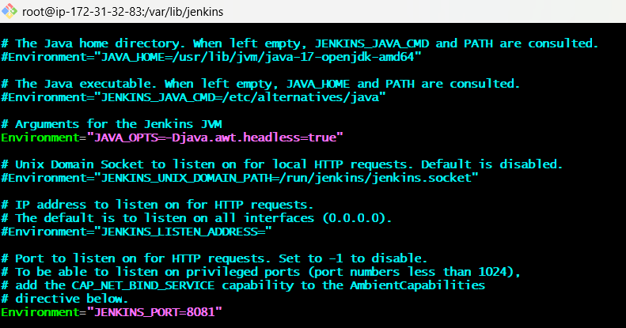
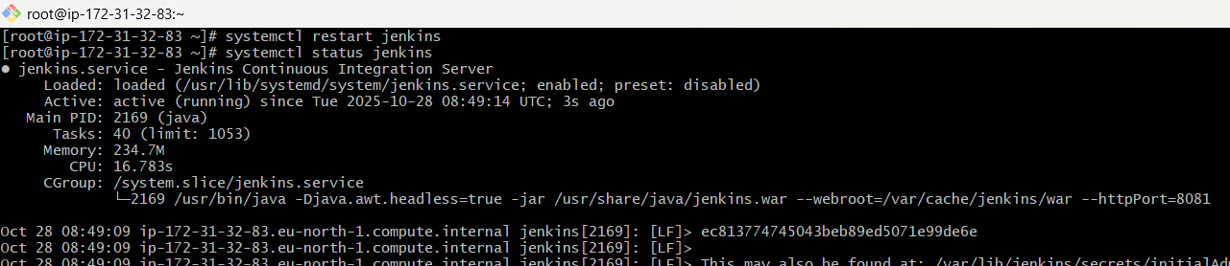
Step 4: Run public_ip:8081 in the browser.
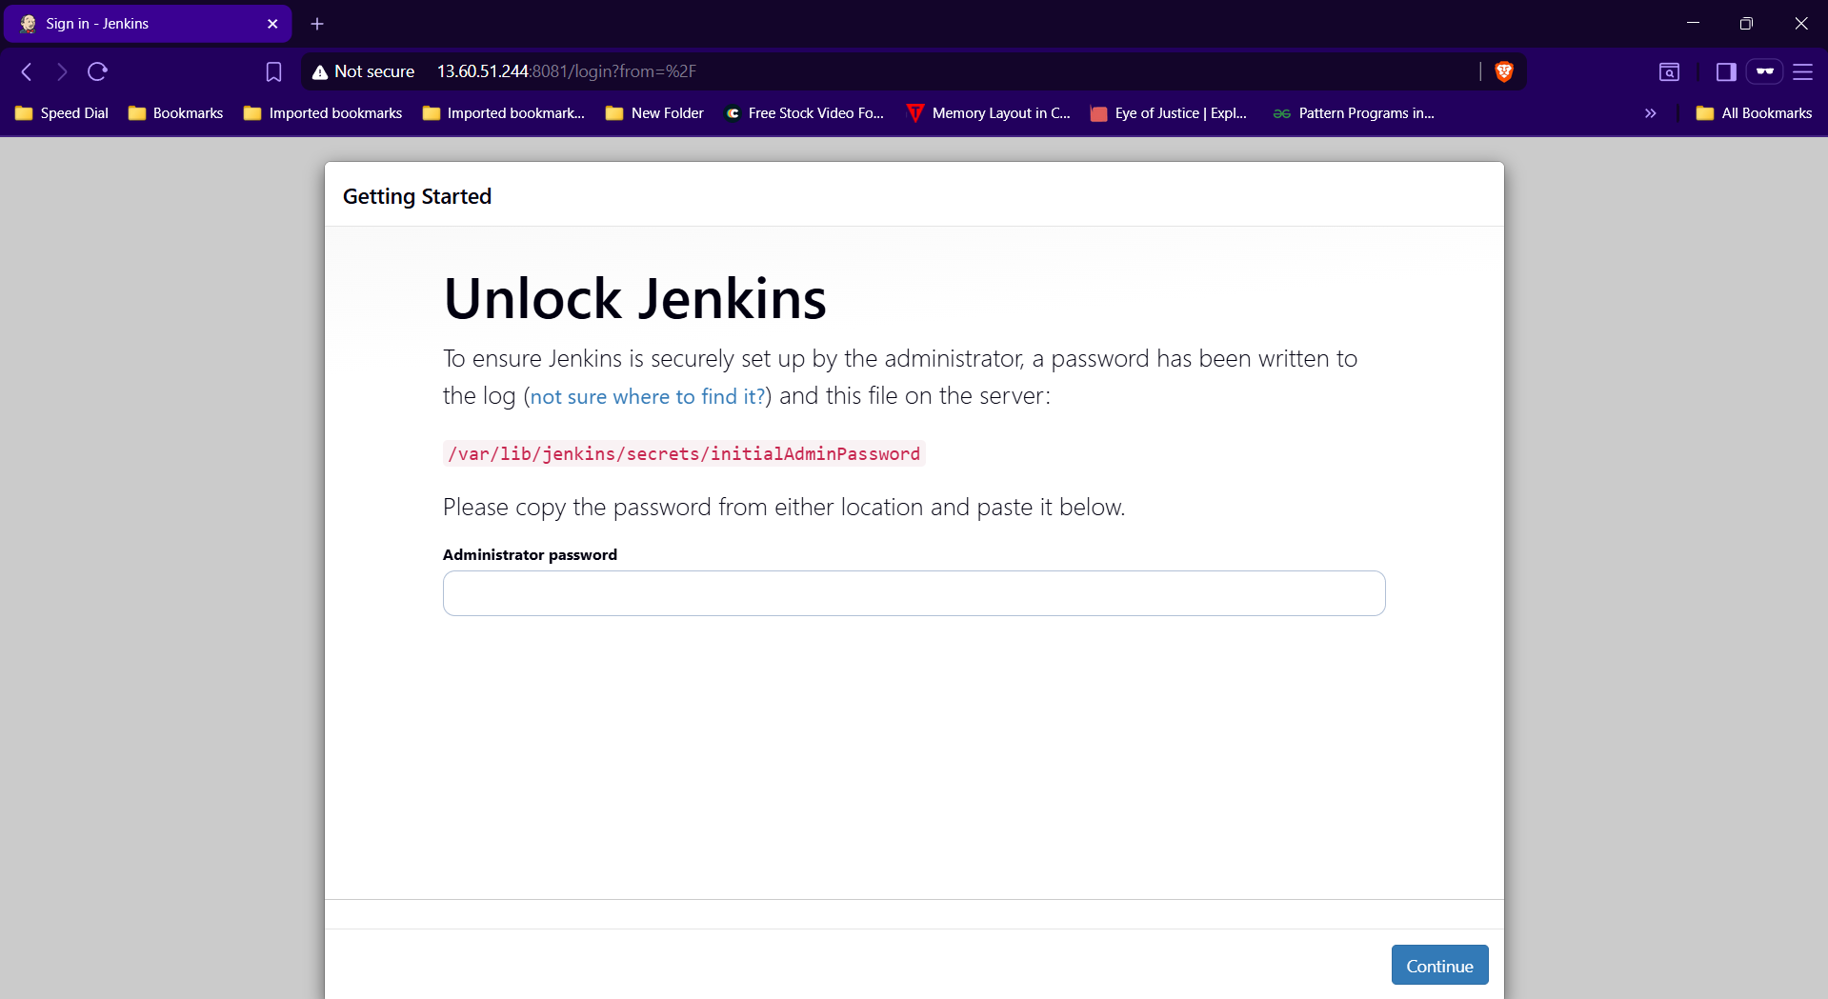

- Secure Jenkins server.
Step 1: Run cat /var/lib/jenkins/secrets/initialAdminPassword, copy and enter the password in Jenkins login page.
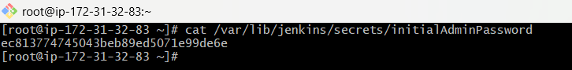
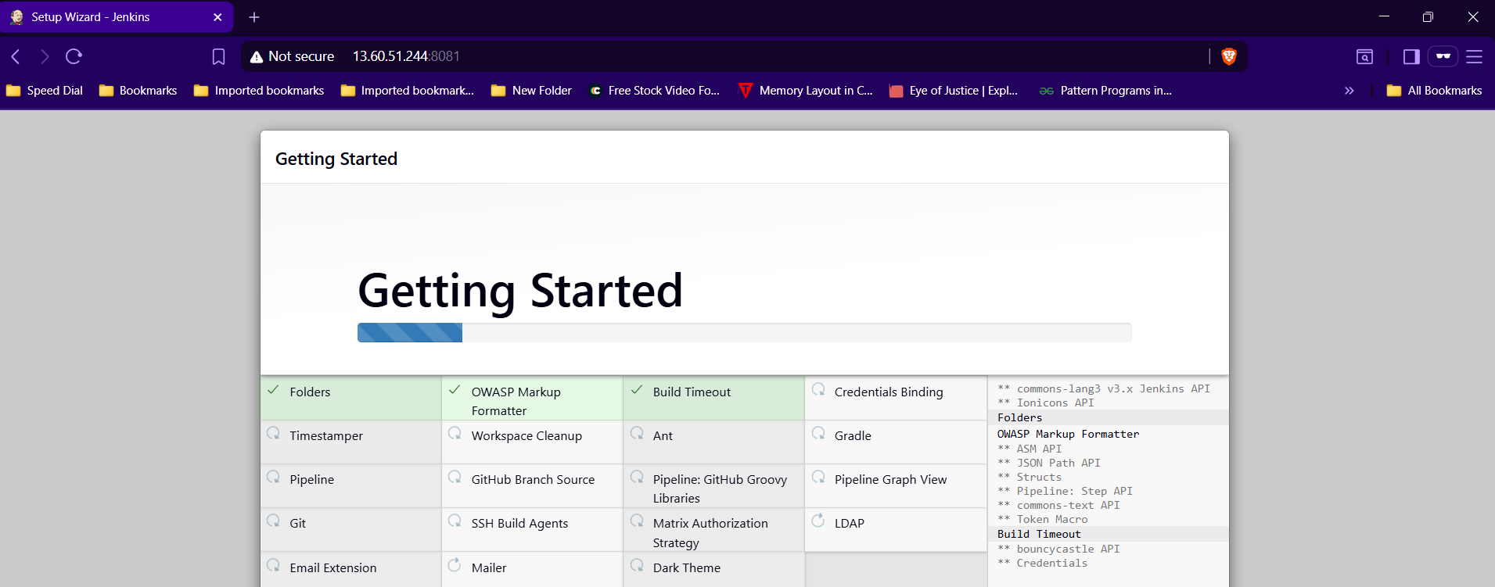
Step 2:Goto security and change the password.
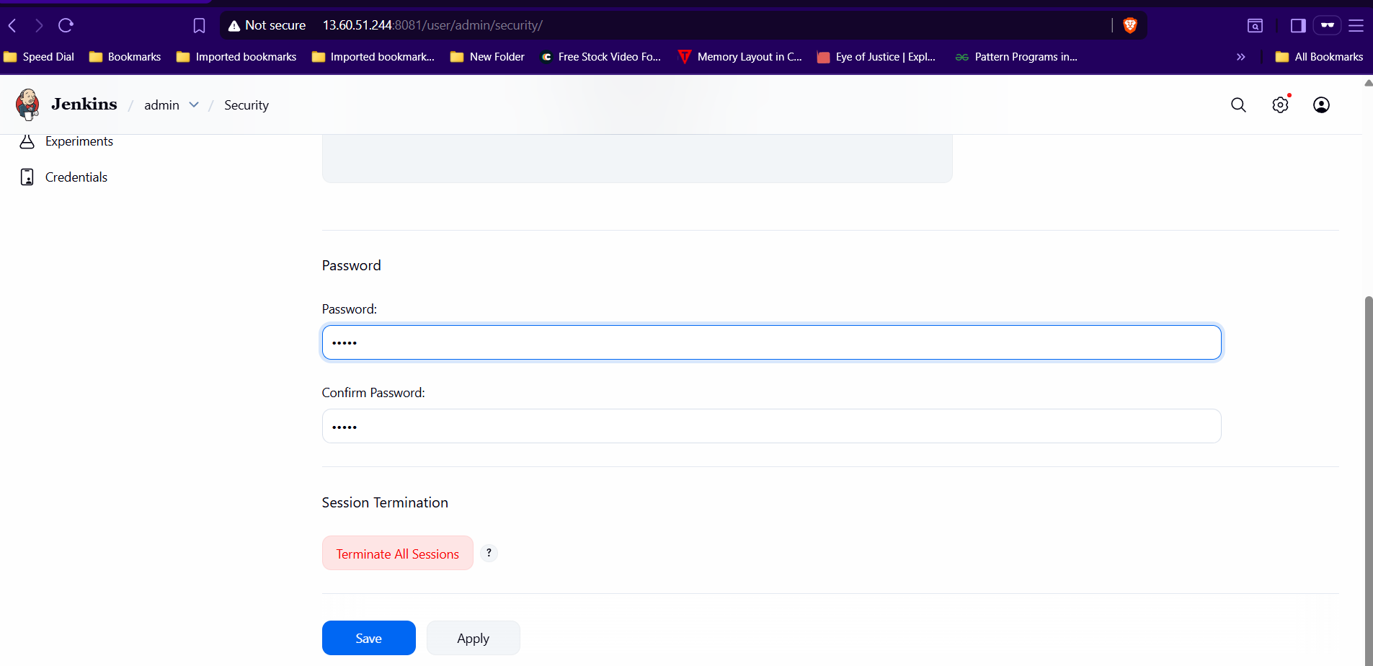
Step 3: Now delete InitialAdminPassword file.

- Create users called DevOps, Testing in Jenkins with Limited access.
Step 1: Goto Manage JenkinsUserCreate userEnter detailscreate.
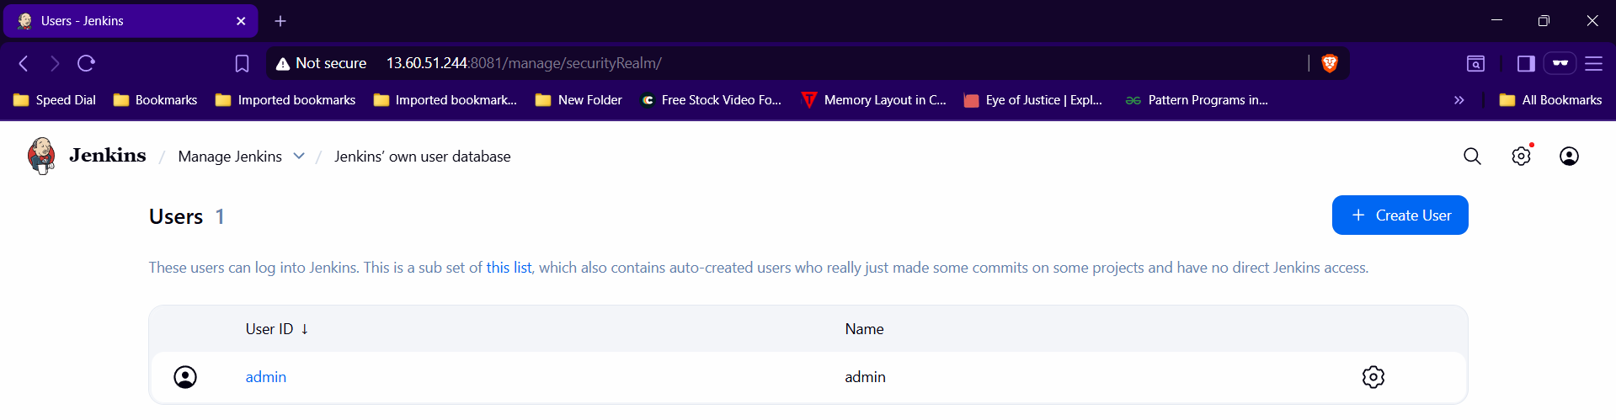

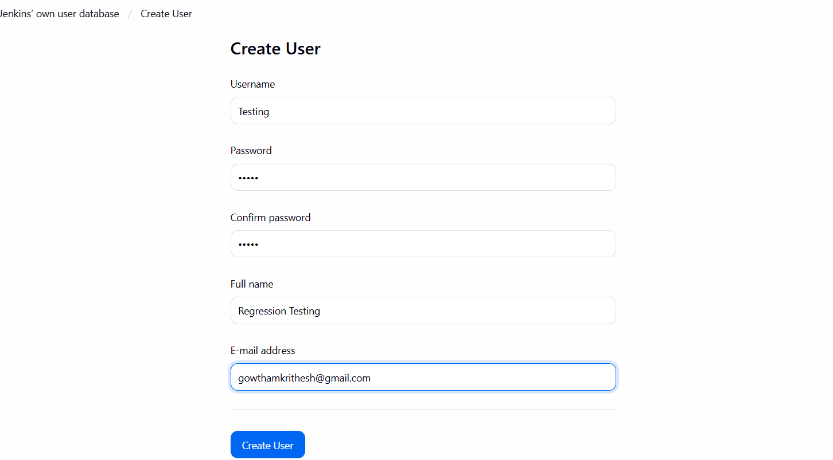
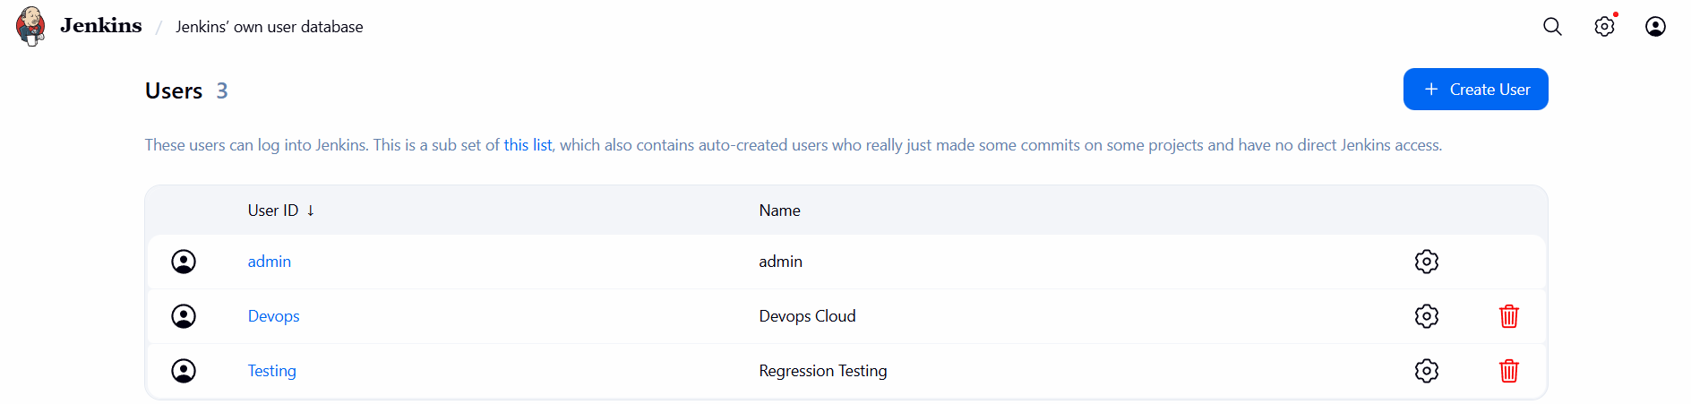
Step 2:

